PARKINSON'S DISEASE
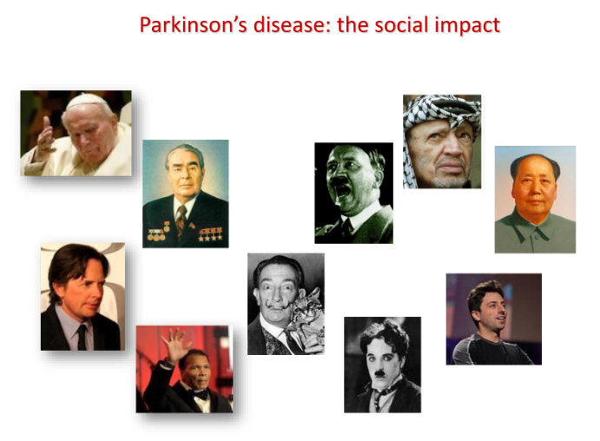

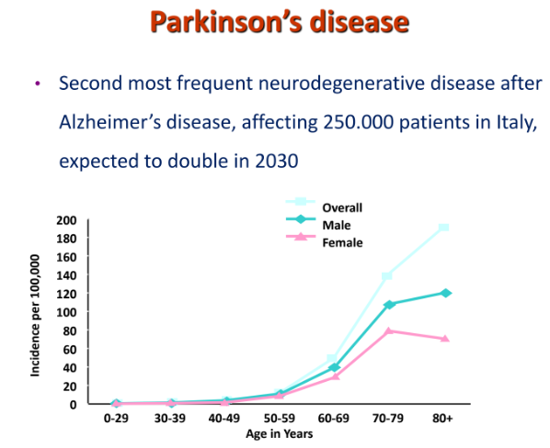
Age is a main risk factor and is occuring not only for parkinson but also for alzheimer

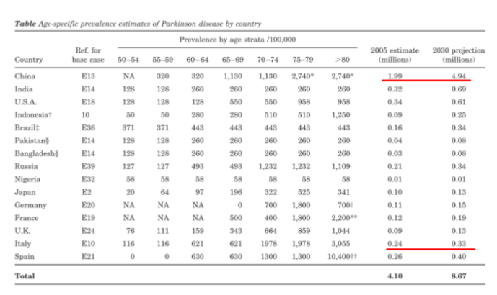
We have a prevision of what will be in the next decade the possible number of affected people in the world. We have some developing countries compared to EU countries that will increase the number much more than what we can estimate.

This is related also to some difficulties in getting the number from some countries (like african countries: hard to make registry of the correct number per pathology of a given disease, we know approximately some value) like in covid-19 we do not have right number from those countries, we have an estimate

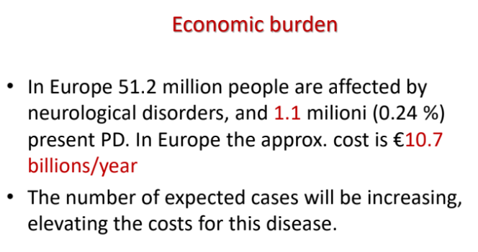
The cost will increase significantly, we spend in euro more than 10 billions per year to cover the cost of these patients.

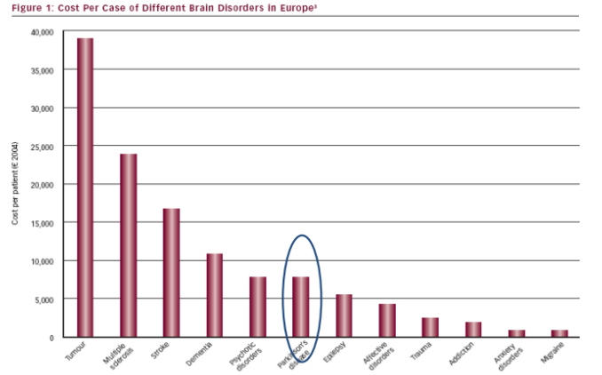
Parkison is 6th, so relatively low condition in terms of expense, but for multiple sclerosis is much more expenives. in the past 4-5 years a number of new drugs have been developed and marketed. The cost of those new drugs are relatively high while the cost of vaccines are relatively cheaper for countries like Italy (western countries, rich countries).

Tumors are one of the most advanced fields in which new treatments have been developed and the costs are extremely high. Most of the new treatments are based on new knowledge, like immunotherapies.
Developed in the last decade. Neurology has been creating new revenues for the treatment of patients.

New drug marketed (in USA yes but in EU no) it is adecanumab (monoclonal antibiotics). Drug that if it will come in common utilization will be higher prices. It is an expensive drug

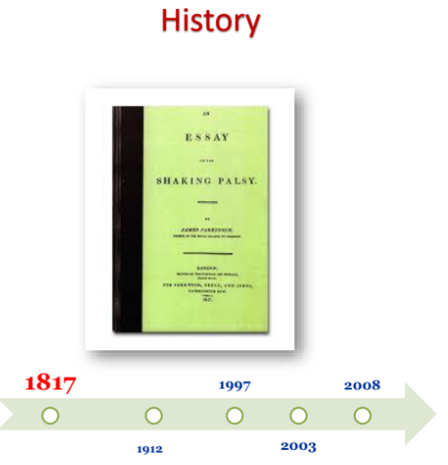

first 1817 description of disease made by a physician who described it as a shaking palsy. (shaking palsy = is an opposite)

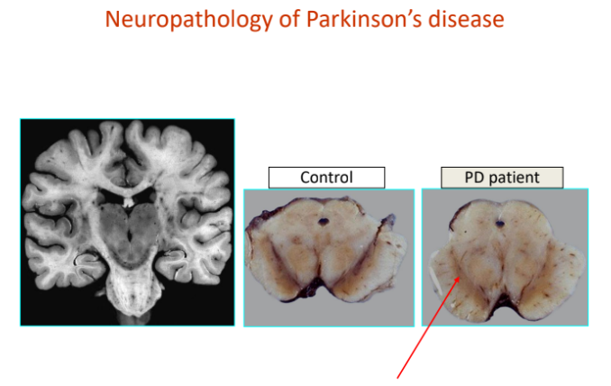
We have degeneration of substantia nigra (called nigra because we have black pigmentation)

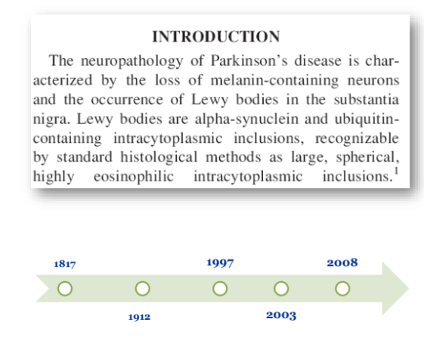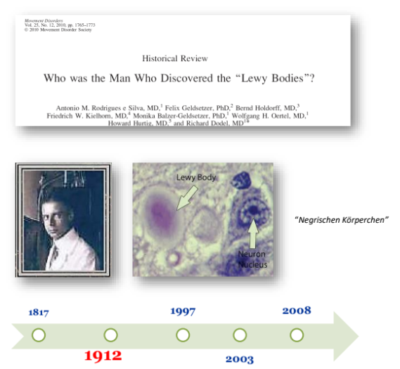

Neuropathology we find Lewy's body. Intracellular bodies that precipitate, they are called lewy bodies after the guy who discovered them.

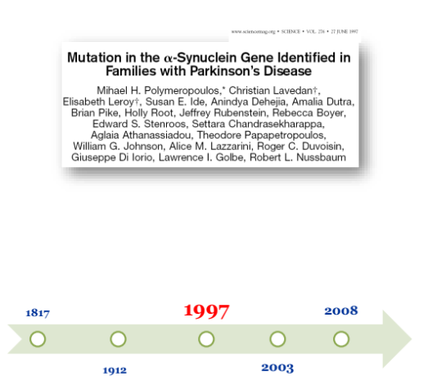

Important discovery was the genetic component in 1997. In the medical field the steps between one discovery and one application (only exception of covid-19) have decades of timeline.
Takes ages from a discovery to the develop of a novel drug and the marketization

alpha-synuclein a group in cambridge found as an integral part

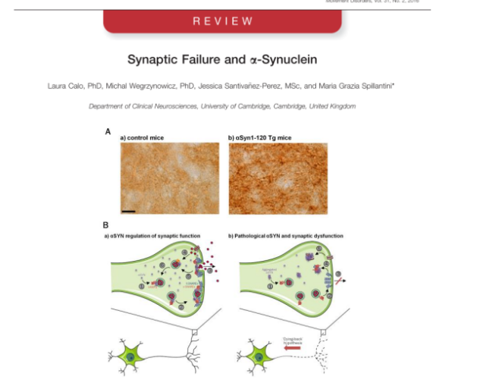
Synuclein is a pre synaptic protein. They have secondary and ternary structures. Protein misfolding is one of the key features of neurodegenerative disease. Proteins that lose track and precipitate by destroying normal synaptic function.

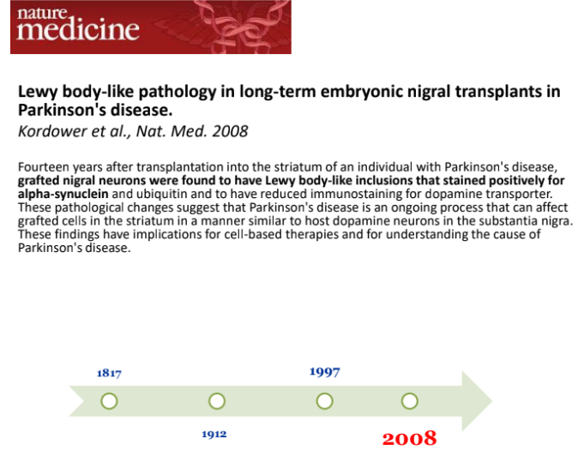
One of the ideas from almost 20 years ago was that if you have black stripes but I am able to put graphs of embryonic cells in that area in principle I could let them grow and substitute what is missing.

In those brains when analyzing the brain of people that received drugs those cells were affected by synuclein pathology.
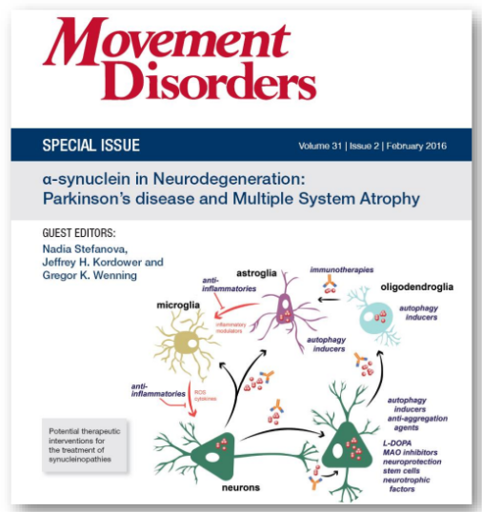
Idea that synuclein jumps from cell to cell and in principle this misfolded proteins can organize in small vesicles and those vesicles normal extracytosis process are released from a cell while with exocytosis are take up from a near cell

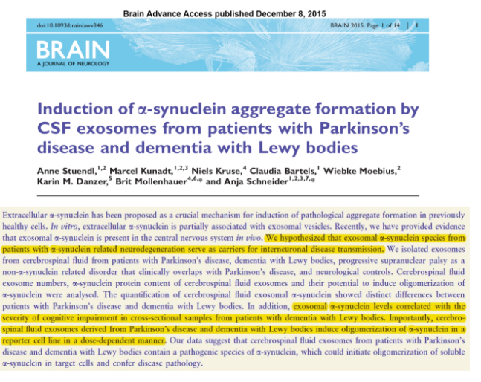
Our brain is packed in a contained under vacuum condition, there is no communication and no connection between the inside and external environment. It is necessary to protect the brain from traumas, infectious agents and so on...
but we have a fluid in between the chamber, this fluid is basically water, like the blood for the rest of the body and is called cerebrum spinal fluid (CSF)

It is in the brain but also in the spinal cord, takes the nutrients to the brain and removes what is detrimental from the brain. It also protects from traumas (like ammortizzatore). It helps preventing.

Those cells either they die and release these exosomes or eventually through and oxytocin release these vesicles containing synuclein. You can transmit from one cell to the other the content of synuclein.

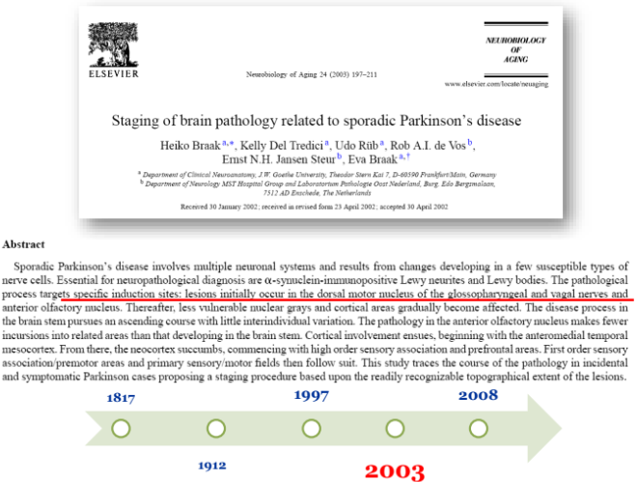

In principle the idea is correct and we can infect other cells like infectious disease .

Analyze brain of parkinson disease and start to process each section of brain and establish we have a gradient in which pathology goes from codal regions to rostral regions

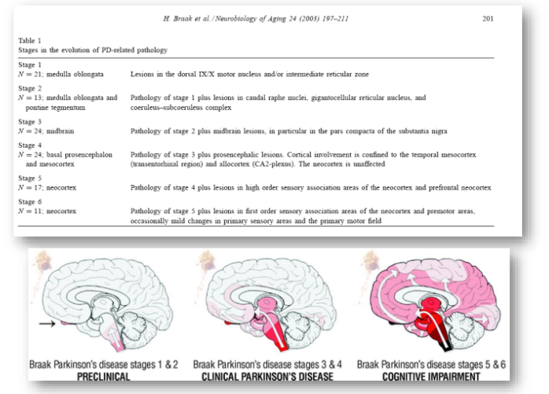

the idea that spreading of pathology fits the idea that synuclein propagates

may have some clinical features but in the end have several signs that indicate involvement of the brain. In the end many patients become demented

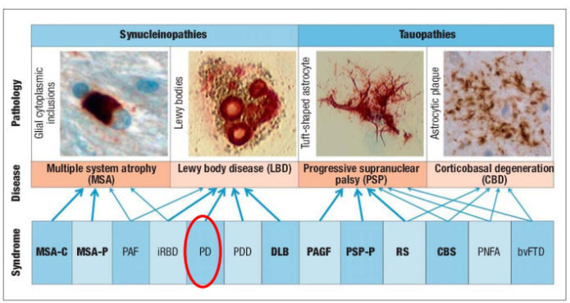
since discover synuclei

In another condition called MSA we have synuclein in cells, so the distribution is different

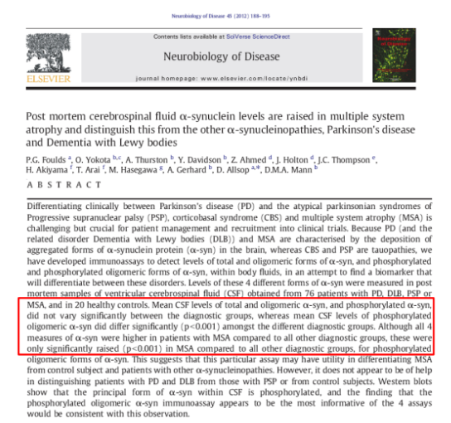

post mortem analysis help discriminate this disease but is useless, you get advancement only from scientific point of view

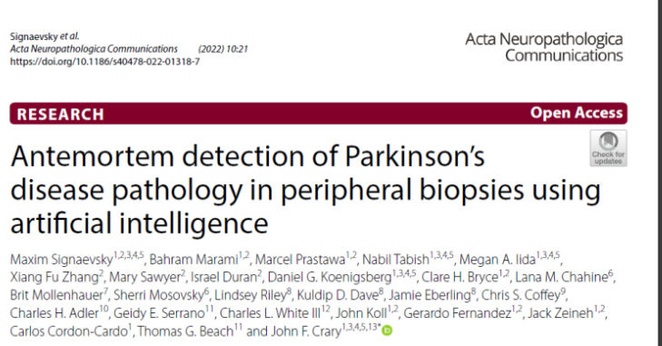
idea that synuclein can be localized in peripheral tissue and sub mandibular glands.

found that you can see the data combining form biopsy analyze data and extrapolate algorithm to get better in terms of accuracy and specificity to diagnosis ante mortem

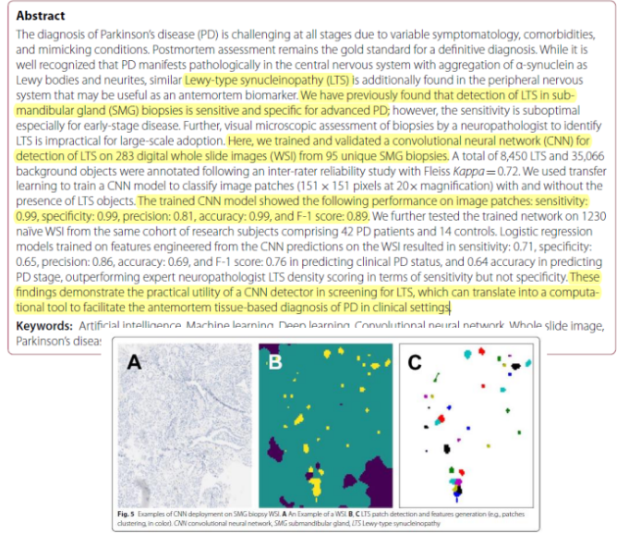
Synuclein aggregate in glands submandibular

We can make diagnosis and detect synuclein, almost 300 slide images from 95 biopsies, total of thousand of objects, and train convolution system with score of sensitivity and specificity

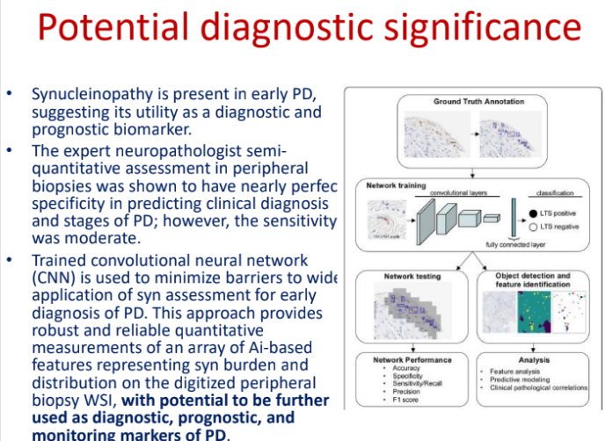
Synucleinopathy is already there in early Parkinson disease. How to serve for synuclein is a relevant issue.

The goal is to simply based on data collected on parkinson disease.

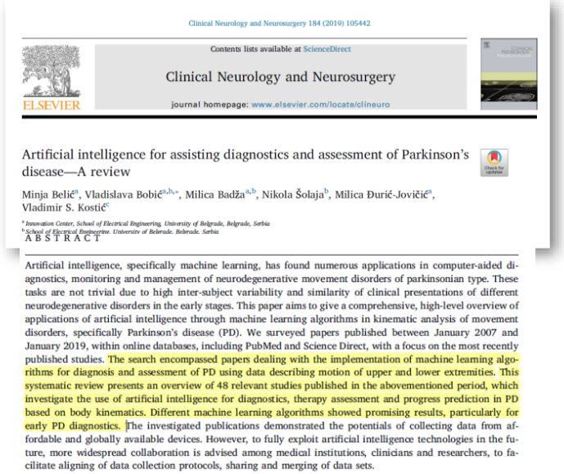

Took 48 of the previous study and put together the main finding. Several algorithms that show prominent result.

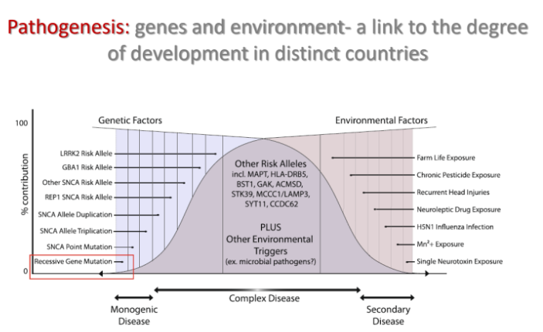
Synuclein plays an important role, there are also some environmental ages. Pestices, herbicides are claimed to be toxic (but never found)

found in a group of pharmaceutical pesticides.

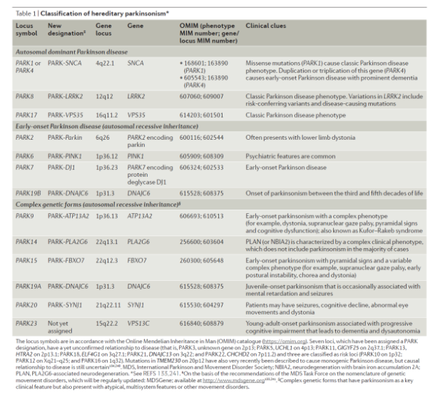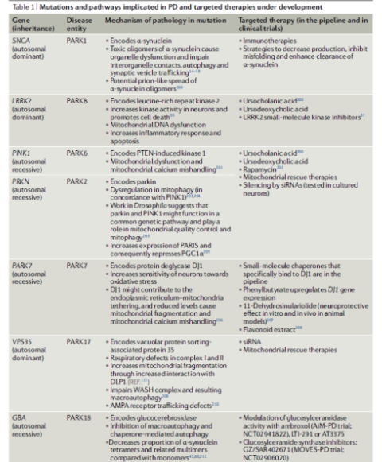

Since synuclein discovery, we have a list of at least 20 genes that are responsible for similar form of parkinson disease, found in apparently non-familiar cases ⟹ these genes represent also risk factors for other forms of parkinson diseases.

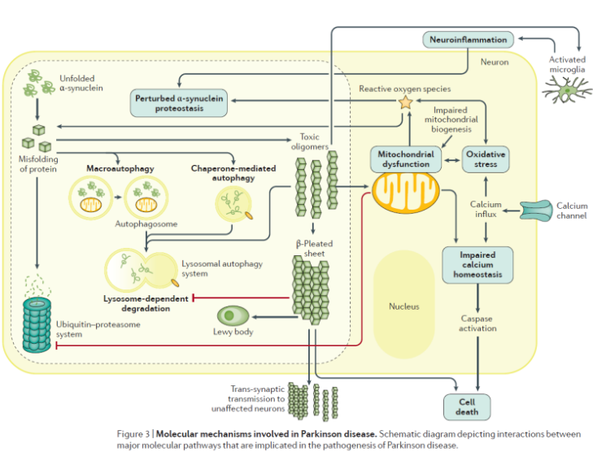

The number of genes linked, found based on dominance, can build up the genetic tree of a family. A number of new genes have been found. In big data analysis already done for genetics, collect blood samples from parkinson patients.

Find that genes have risk factors. Patients even without family history means that genes are involved in risk factors.

This list of genes helped to get details of molecular counterparts. We have the idea that synuclein is not alone, there are a number of genes involved in several cellular functions.

Mitrocontridrial (ATP) for the energy of a cell, is the center of state for aging. Mitochondria are the key responsible for aging. If you manage to take care of these organelles you can prolong viability of single cells and so of the entire body.

We need to understand how to improve the viability of mitochondria.

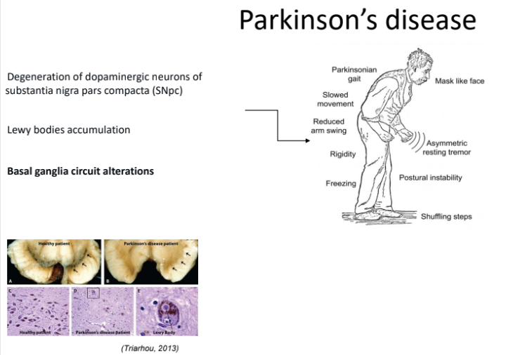

something really changed in the field. In the clinical part of the story we have a typical motor signal

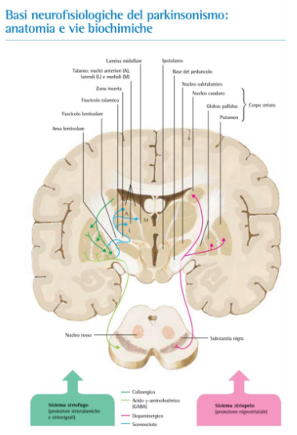

We get abnormal circuitry of basal ganglia. You do not have any more dopamine

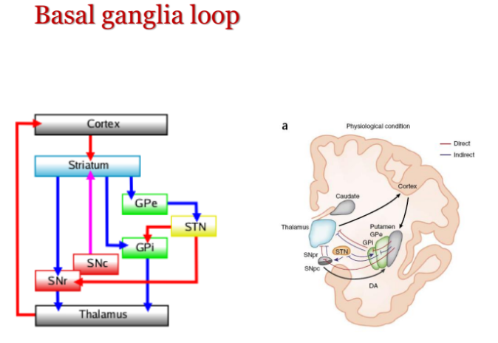

We have a loop and dopamine is essential to give dopamine to striatum and help regulate the circuitry. When you take it out lose normal function of system

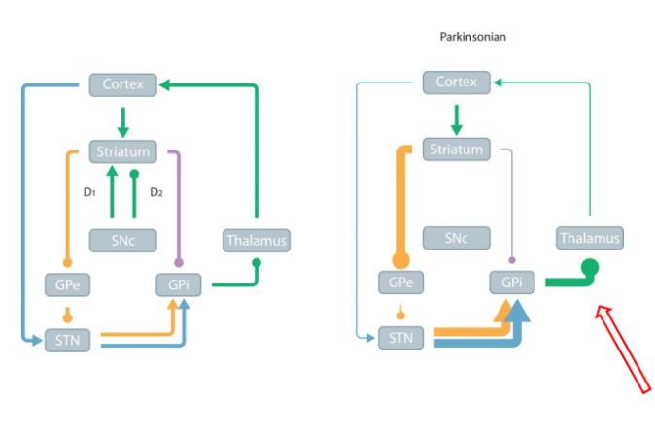

The right loop we have less feedback from thalamus to cortex, cortex able to send a signal to the loop but is less efficient because the loop is impaired

The bold signal between GPi and thalamus is inhibitory and utilized gappa.

You inhibit thalamus and thalamus can not send back the same message to the cortex.

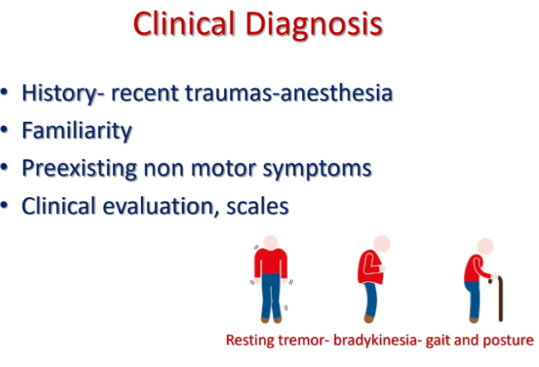
Need to get a patient's history and try to understand if there is a family history.

than search familiarly
Even if they have a recent trauma or anesthesia.
It looks like general anesthesia can unmask an underline degeneration, accelerating the degenerative process. Anastasia is like a reset of a pc, shutting down brain activity.
In the end of anastasia and you wake up then start showing motor symptoms.

Ask for non motor symptoms

for motor symptoms have typical

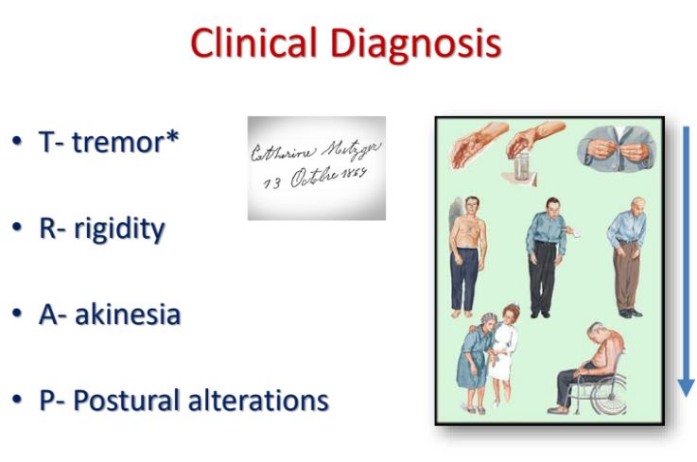
have typical

- T - tremor: resting tremor evident when people is not doing anything
- R - rigidity, increase in muscle tone
- A - akinesia, slowness of movements
- P - postural alterations because posture is maintained with basal ganglia system that have to readapt

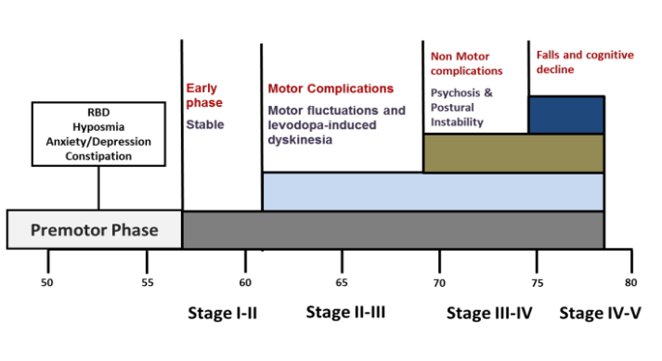

20 years on stage. Clinical symptoms can be regulated by cortical (upper) regions, degeneration have a direction from lower part of the brain to an upper part of the brain

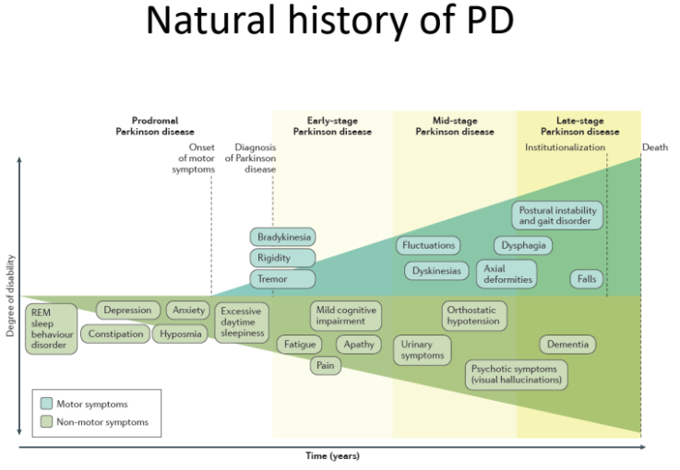
Asking patient if experience sleep problems, depression, anxiety, hyposmia (lack of smell) are consider PRE-motor system and according to Braak hypothesis this feeds
all centers that regulate sleep are even lower than substantia nigra.

If you consider that now we have solid evidence with REM sleep behavior disorder (phase that you are unaware of what is happening, you are completely anatomic, muscle are not controlled), patients tell you that have abnormal movements or kicking the other people sleeping

Sometimes people fall from the bed to the ground and don't know why. Those guys once they undergo a sleep analysis you see abnormal electrical counterparts of the sleep disorder. There is almost 90% conversion to parkinson.

Population that sooner or later will become parkinsonia. This feets like retrospectively interrogating patients that they had this sleep disorder.

If you find a cure you treat those patients, so that they prevent disease.

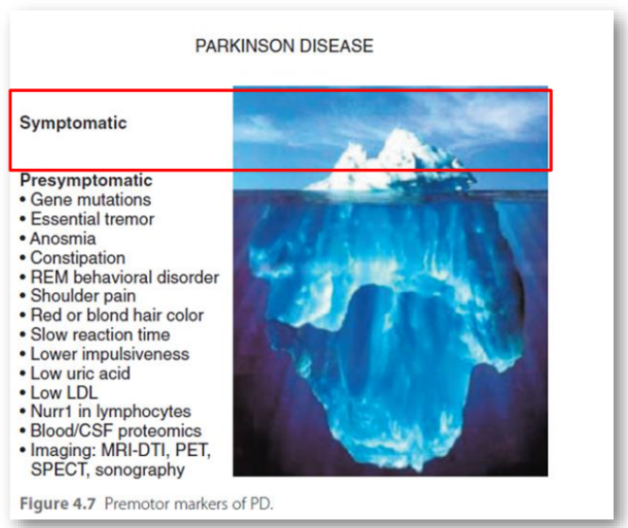

Have to go back and ask them if they have huge number of features in the past (even 1 decade earlierS)

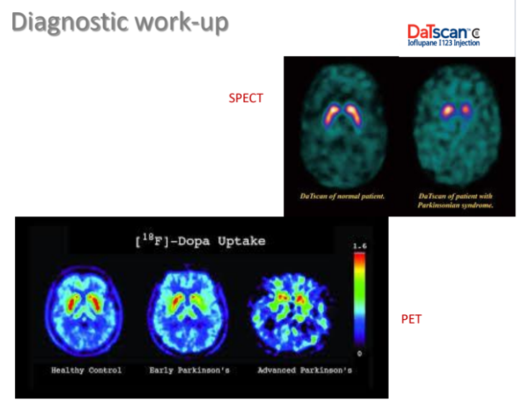
For suspect of parkison use Ioflupane marked with iodine (iodio)
goes straight to striatum and marks the terminal
DaT (dopamine transporter).

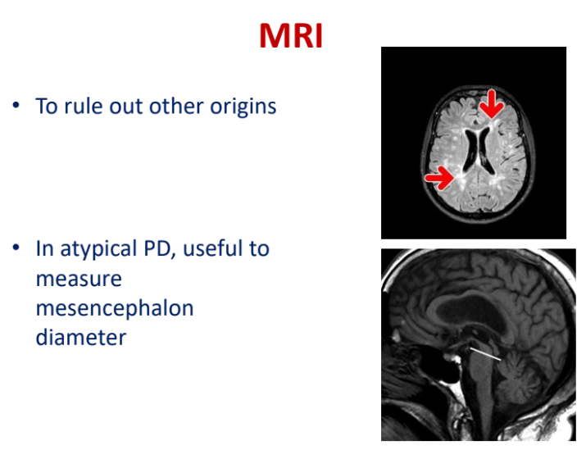
There are hundreds of papers of analysis post processing with different resolutions.

3 tesla powers and we have 7 tesla machines goes to anatomical

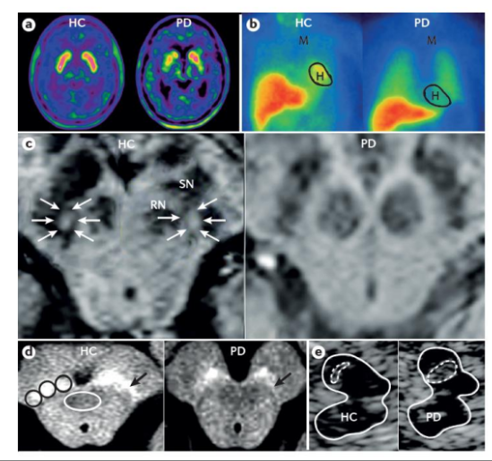
With echo, is unreliable, is like a sonda that you use for echography. If you put in a specific window you should be able to see...

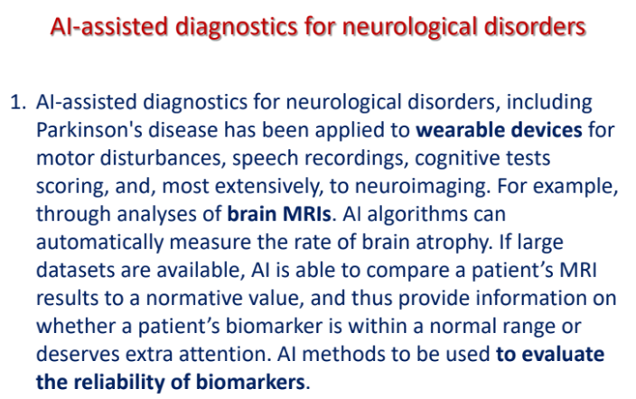
AI have huge potential for neurological disorder, use wearable devices connected with bluetooth that record movements and generate some data, use to detect subtle changes,

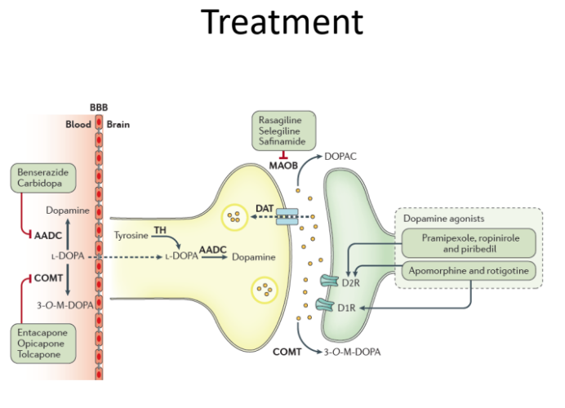

We do not have drugs, we have only drugs that substitute dopamine, we have dopamine precursors or drugs that inhibit dopamine decrementation.

Thanks to dopamine they live almost normal life, but as a replacement, we are not curing dopamine. If I take dopamine medication off the patient will be in a similar (or worst) condition to when it started. It is a replacement

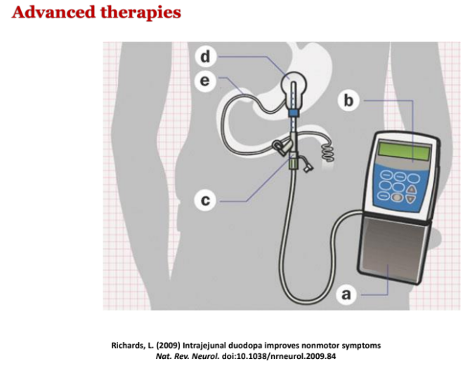
Replacement can happen with pimps. Is a intrajejunal that have to be implement in the jejunal of patient, have to make a small but still interventional approach to deliver dopamine

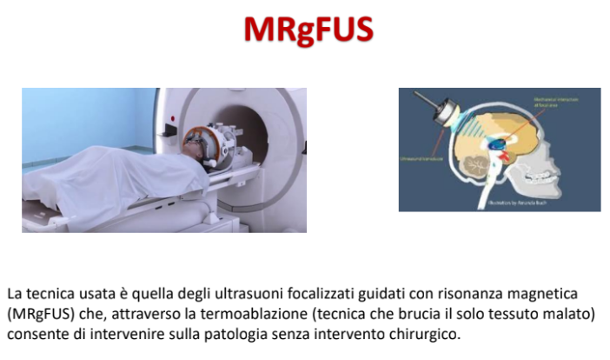
It is an invasive procedure, focus ultrasound. Thanks to imagining we have a guide to basal ganglia region and thanks to those imagining guidance we can target signal region of brain and can send ultrasound to destroy a small region
This is well suitable for tremors. Can have a relief method

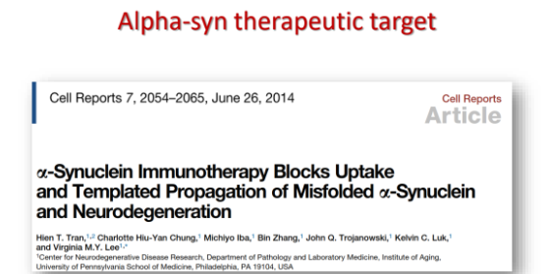

so far trials failed, no benefit to the patient

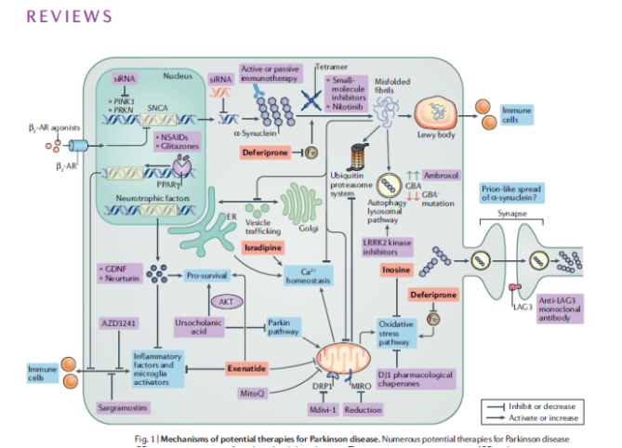

There are a number of treatments
DRUGS REPORUPSOED: one idea is to use a common antibiotic, has been proposed that there are some drugs (not necessary on the market or abandoned one) and are part of orphan drugs, those orphan drugs are not utilize, if though the development a new discovery you find a match. Take old drug and you make a trial, you repurpose an extinct drugs

advantages
- cheaper: already developed drug, take data form number of studies and try to make a match

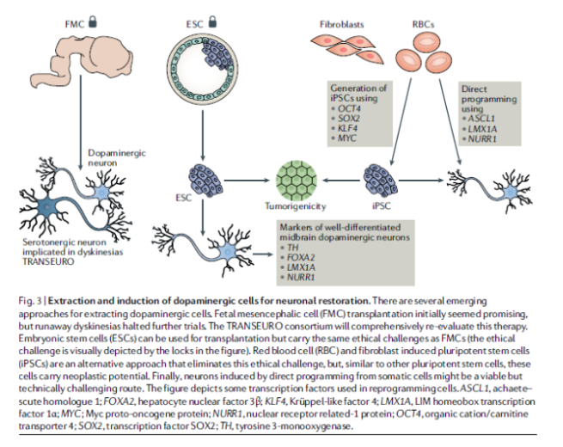
a skin cell can become a neuron, just reprogram their life, once you have tens of those cells you can use them as neuron, you take skin and you convert it

AI AND VOICE IN MOVEMENT DISORDERS

Wearable devices
It is a new world approach start few years ago (not more than 10) by analysis of voice in pulmonary disease

One of groups that started this was a group studying TBC in india, try to make diagnostic match analyzing voice and x-ray chest

Found that voice analysis was extremely good in predicting the presence of TBC (tuberculosis)

since them there is a huge development

| the human voice
The human voice is extremely complex, come from multiple elements, adduction and vibration with combination of air from the lungs and larynx and tracked tube

...

|t he human ohinogiclas

Massive involvement of brain when we speak

| voice disorders
organic

functional; psychiatric can be in different ways

| diagnosis: layngoscopòy
We can have diagnostic tools to investigate the voice

Inserted from nose and analyze vocal cords to see how they works
See vocal cords how they change contraction and tell if they are working or not

| voice analysis

In analysis of voice there were people that recorded voice to try to predict a way to make qualitative analysis of voice.
in the 80s have been technological advance, this type of analysis strongly depends on technology, like compare studio recording from 60s and cd recorded now quality is completely different

# voice analysis #2
Several techniques like spectral analysis to analyze some features of voice, very specific and detailed parameter than engineers have been analyzing analysis 300 parameters of voice, just analyze form a single sentence which then helped to create a ML saooraoch

| voice analysis #3?
Spectral analysis,

| ML and voice analysis
Use a ML algorithm to study the single paraments and features of the voice with the ability to extract thousands of parameters from a single signal. Then it is a sound signal

| ML and voice analysis #2
Spectral record and make quantitative measures

| aging/gender and voice
Aging changes your voice (linked to physiological aging) change intensity, type of phonetic and general worsening of voice quality
hormones makes a significant difference between male and female

Hormones in menopausal phase will change voice in women

Parameters are completely different, this is related and linked to that language. You set parameters on that language because vocals, consonants rhythms change between countries to country

Can be valid unless you use a sound like AAAAAAAAAAA, but still different from country to country

| essential tremor
Tremor that is not parschonal tremor, does not degenerate
goes along in a person life for older life without being so invasive, it is just boring

can distinguish easily

can takes hundreds of parameters to analyze voice

| brain

Essential voice tremor are localized in specific areas of brain wrt to essential voice tremor
you can have dystonic voice, in this case regions are different, it is really comply, can make a sort of disticon

|graph
we can see difference between helrtj dsines

|parkinson disease (PD)
Parkinson lower volume, sam patient before L-dopamine (before and after treatment)

